Tips for Navigating the Lyon County Fair
Blue Ribbon Fair Online Pre-entry System

To manage your family under one account with one ID and password, you’ll want to enroll under a Group Account.
(If you only have 1 (one) 4-Her you can create an individual account, but a group account is also OK.)

Go to https://www.BlueRibbonFair.com/BRFairProd/BlueRibbonStart.aspx?ID=1489

STEP 1:
Click “Create Account” and select “Group Account”

For your Nickname, please use the 4-Her’s Primary Parent’s First and Last Name followed by Family.
Example: Corinne Patterson Family

You’ll create:
a User Name (can be anything),
create a password (can be anything) and
enter your email (make sure it’s one you can access).
Identify a security question.
Accept Terms
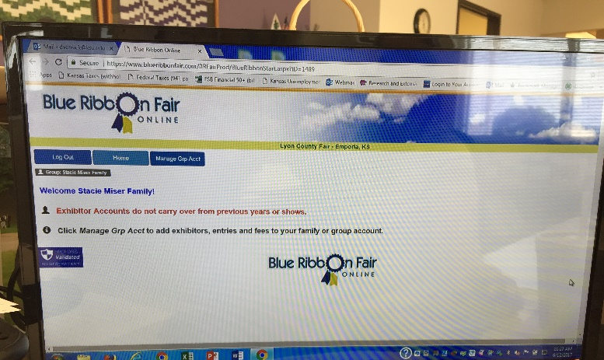

STEP 2:
Now that your Family Account is made, you’ll add your 4-Her’s by selecting:
“Manage Grp Acct” then,
“Add Acct”
Enter specific data on your 4-Her, including birthdate. Enter his or her 2016/2017 grade for school.
Save Info

You can make additional accounts for more family members.

STEP: 3
Making Entries.

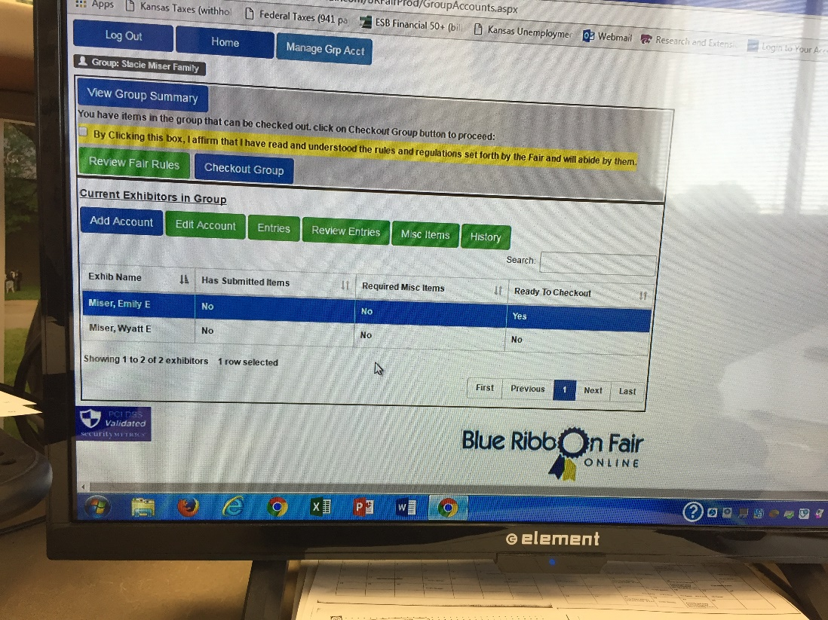
Once you have your 4-Hers created under your group account, you can then select or highlight one 4-Her to begin making Entries by clicking on the “Entries” tab.

You’ll select the Department at the top and then you’ll see the class options and specific entry options. It should limit the 4-Her based on their 4-H age for the correct category.
Click on the + button to see more specific entries (if the option exists).
“Add” will add the entry to the 4-Hers account.
- Be sure to wait for the “Entry Added” message to appear and process before trying to enter an additional item.

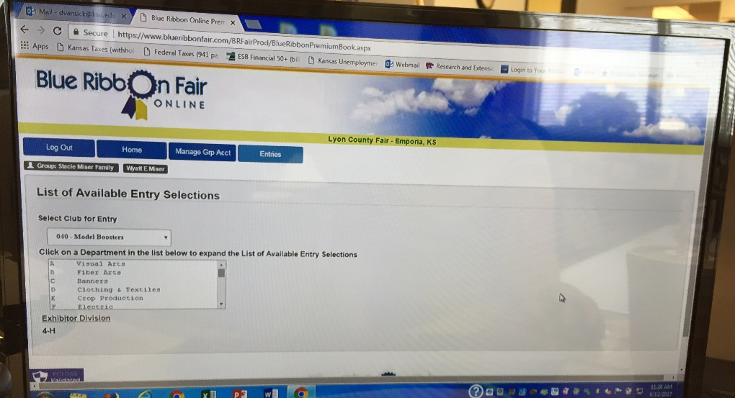
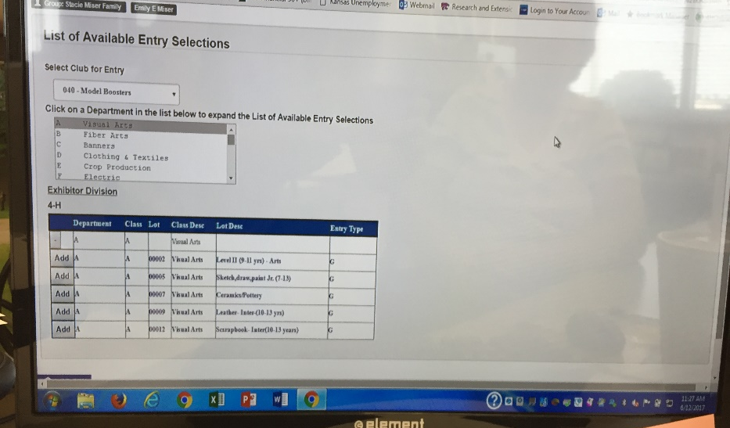
Livestock entries will ask for a Tattoo/Ear Notch number, which is where you should indicate the 5-digit visual number from your official Lyon County 4-H tag. Please try to put the correct Lyon County 4-H livestock tag number in this field that corresponds with the 4-Her who will show this animal. While things can change, we know most exhibitors should know what animal(s) they are bringing to the fair to show in the appropriate class. It’s also a reminder to check tags because any tag that is missing from an animal and not made known to the Extension Office prior to July 1 may not be replaced and the animal will not be eligible for the fair without an official livestock tag.
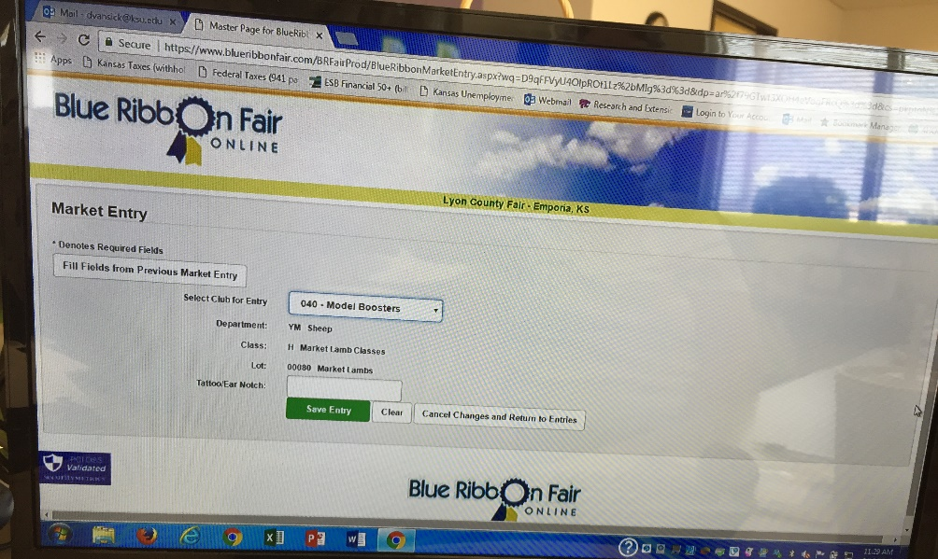
Each Department (project area) is listed and by highlighting the area you wish to make an entry, options will show below. You will use the “+” button or “Add” button to add the specific item you wish to enter. You will see a “saved” or “submitted” message when you’ve added a specific item.

You can continue adding items for this 4-Her. When you’ve added all items for this 4-Her, you can return to your group page by selecting “Manage Grp Acct” and make entries for the next 4-Her.

STEP 4 (Review):
DO NOT “Check Out” until you are certain all your 4-Her(s) pre-entries have been made. It may prompt you when you toggle between pages, but do not Check Out until you are completely finished entering your family in the fair. You cannot make changes once you’ve checked out.
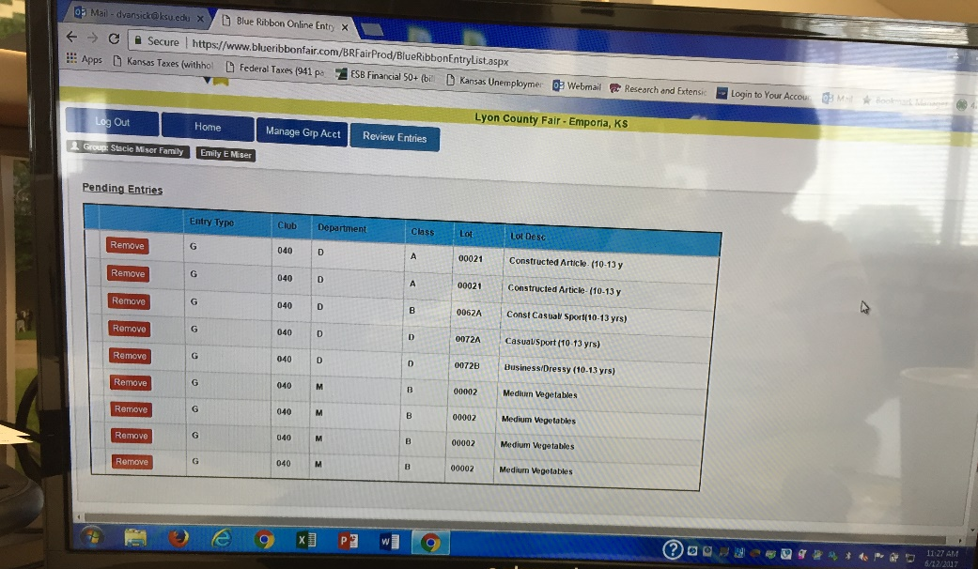
You have the option to “Review Entries” before you make your final submit. You can add or delete until you “Check Out” to make the Final Submit. This means you can log out, come back a day or so later and still make changes, so long as you haven’t made you entries final by “Checking Out”. It also means that you have to make sure that you make your final submit prior to the July 1 deadline. The system will go down at 11:59 on July 1. Please do not wait until last minute to make your final submit. But do know you can log on, create your account and begin making entries decisions right now and come back to your Login and make changes/finalize before July 1.

STEP 5:
Execute the Final Entry process for each 4-Her by selecting “CHECK OUT GROUP”

Other NOTES:
Don’t use the back arrow on your browser. Be sure to use the HOME Button or the MANAGE GRP ACCT buttons to move between pages.
Please read your fair book carefully. It’s available online and will help you make the proper class selection for the item your 4-Her wishes to enter in the fair. Also, you can only enter in project areas for which your 4-Her was properly enrolled in by the May 1 deadline. Please check your 4-H Online Account if you wonder if your 4-Her was enroll in an area or not. Remember, enrollment in a 4-H project is not entry in the fair. The systems are separate.

Review projects in which your 4-Her is enrolled by login here:
https://ks.4honline.com/Login.aspx?403D4065476E5551444A414B68513D

The printed fair book will be available at the Extension Office and various business in the county soon. The online PDF can be accessed at:
http://www.lyon.k-state.edu/4-h/county_fair/

